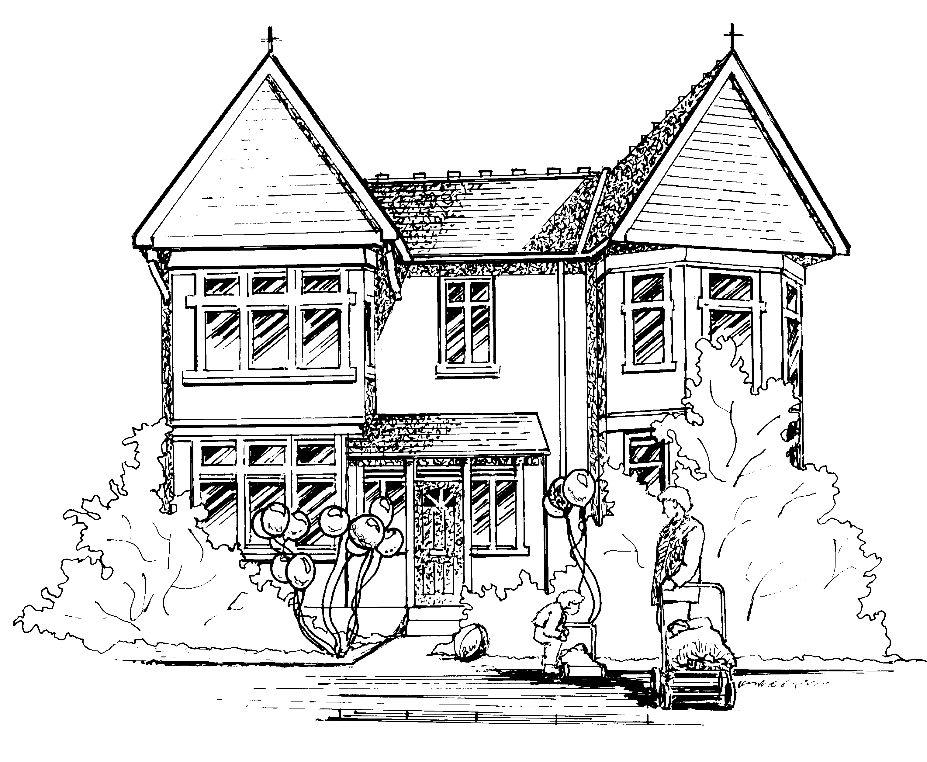

Weekly Newsletter

Hi all,

Baby Room
This week the babies have been continuing to learn and explore the colour green. Next week they will be learning all about Australia as it is where Evie’s Mummy is from. If you have anything you would like to share with the group from Australia please feel free to bring it in.

Toddler Room
Toddler Room have been learning about different forms of transport this week. Next week they will be learning about ‘My Body’ focusing on their body parts.
Margot will be transitioning into Toddler Room next week.

Pre-School and Nursery Class.
This week we have been doing profile week, focusing on our children’s next steps for learning. Next week our focus children will be Adarsh, Arrian, Arjuna and Arjun.

Our letter of the week will be ‘K’ Kicking King, if you could encourage your child to find an object beginning with this letter for them to show to their peers during group discussions.

Nursery class will be focusing on the sound “ew‘’, if you could help your child to think of words including this sound such as ‘jewels’, ‘news’ ‘view’ etc.

Notice
Please avoid overdressing your children whilst at nursery as we have noticed lately that many children have been coming in, in several layers and this could cause over-heating. The majority of parents come to nursery by car, it is warm in your car and warm in the building. Research can be found at www.lullabytrust.org.uk

Nursery Review
We still have not had any reviews yet. We would appreciate it if you could please log onto www.daynurseries.co.uk and leave a review on our nursery page regarding your experience with us.

This week’s menu is attached to this email.

Many thanks
Claire.

