Weekly Newsletter
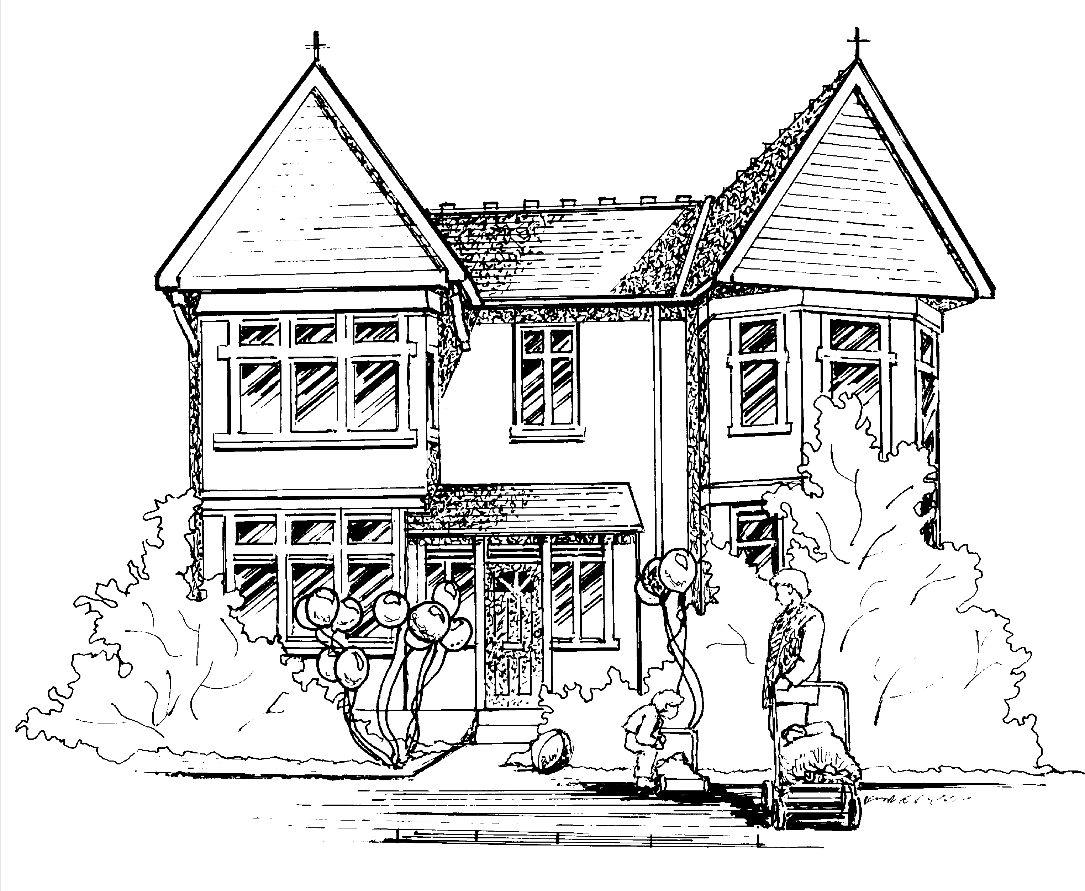

Hi all,

Baby Room
Next week the babies will continue to learn about Spring. Jackie has asked again if all babies could bring in a photo of when they were first born to see how much they have grown.

Toddler Room
Toddler Room will be learning about animals on the farm. They have asked if the children can each bring in a farm animal that they would like to share with the group.

Pre-School and Nursery Class.
This week the children have absolutely loved learning about pirates and have all taken on the role well making a ship, hook hands, eye patches and treasure maps. We have also had lots of fun with water in the garden and are asking parents to please provide waterproofs and wellies so the children can enjoy and explore in the water without the worry of getting wet! Next week we will provide opportunities for the children to learn more about the season Spring as we explore the weather, flowers and animals.
Next week our focus children will be Elliot, Emily and Erin.

Our letter of the week will be ‘b’ Bouncy Ben if you could encourage your child to find an object beginning with this letter for them to show to their peers during group discussions.

Makaton.

Makaton is a language programme that uses signs and symbols to help people communicate. It is designed to support spoken language and the signs and symbols are used with speech, in spoken word order. Today over 100,000 children and adults use Makaton. Livon and I (Claire) are fully Makaton trained and will be implementing this throughout the nursery by teaching the children basic signs and using the suggested Makaton sign of the week. I will have a display of what the sigh is each week in the hallway and in Pre-school. If you would like to find out any further information, please check out www.makaton.org or speak to me personally.

Many thanks
Claire.

