Weekly Newsletter
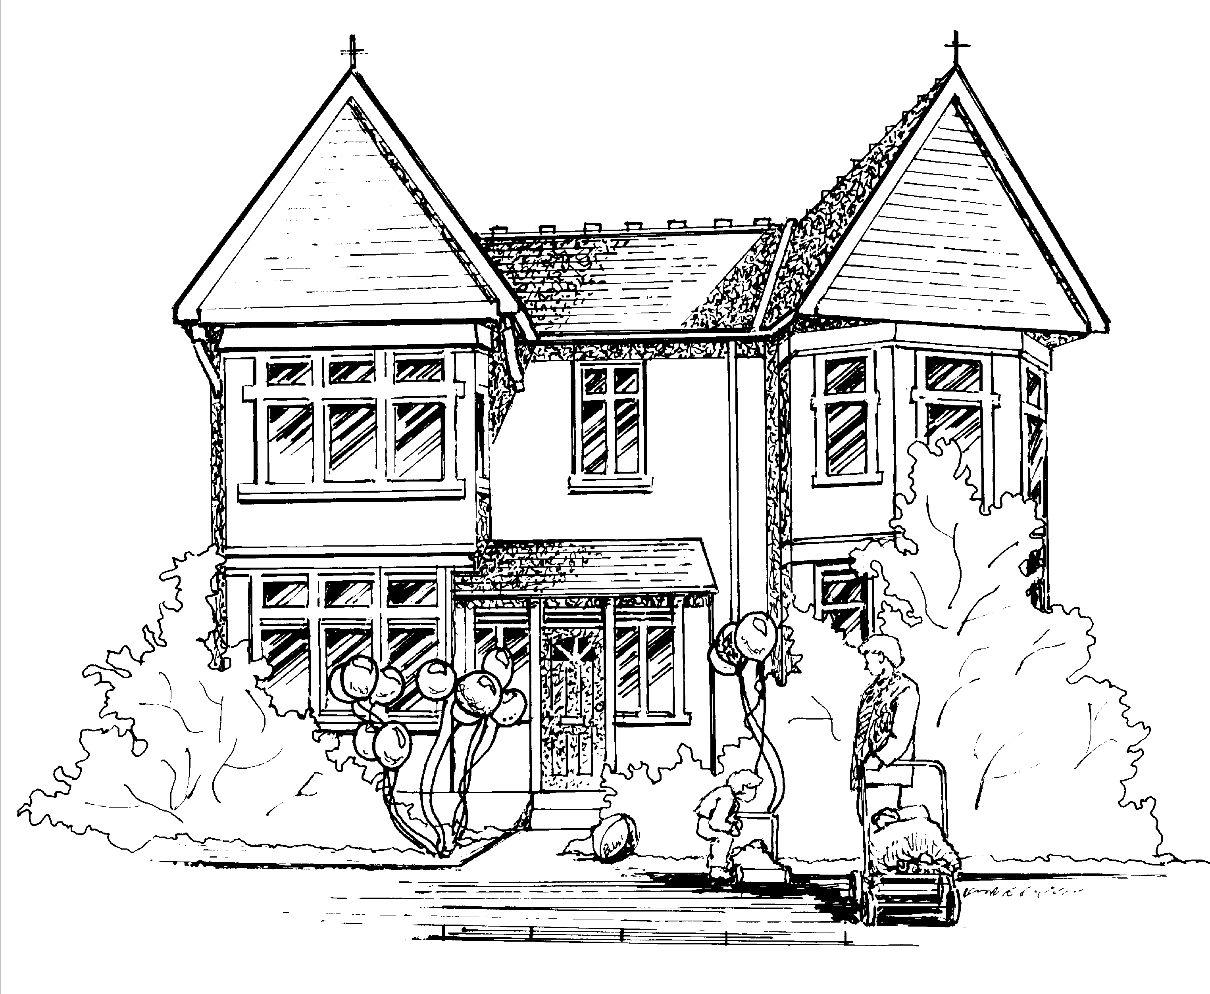

Hi all,

Baby Room
Over the next few weeks Jackie will be alternating between Georgia and Victor as focus children as they are the only two children in the room until our new babies settle in shortly.

Toddler Room
This week the toddlers have enjoyed working on their fine and gross motor skills during physical week. They enjoyed using the balls to practice throwing, rolling and kicking in the garden and took part in threading activities using beads and string.
Next week Toddler Room will be introducing ‘In the moment planning’ I will send a separate email advising on what this means for the Toddlers and their parents!
The focus children for next week will be Alessia and Lex. If parents can please fill in the focus sheet and return it back to us next week.

Pre-School and Nursery Class
This week the children have really enjoyed making a fire station. They all have been taking on the role as a firefighter using the hose to put out fires and rescuing animals from the tree using the ladder. They made up different scenario’s and thought about what equipment was needed for the emergency before driving in our fire truck that we made from recycled modelling. They have been learning how to use the walkie talkies to communicate with one another.

Our focus children next week will be Maddy and Margot. If parents can please fill in the focus sheet and return it back to us next week.

Our letter of the week next week will be ‘S’ Sammy Snake if you could encourage your child to find an object beginning with this letter for them to show to their peers during group discussions.

Notices.
Makaton
This week the children have been learning the Makaton sign for ‘hot’ For information on Makaton please go to www.makaton.org

Annual Leave
Next week Jackie H and Jackie S will be off all week.

Many thanks
Claire.

