Weekly Newsletter
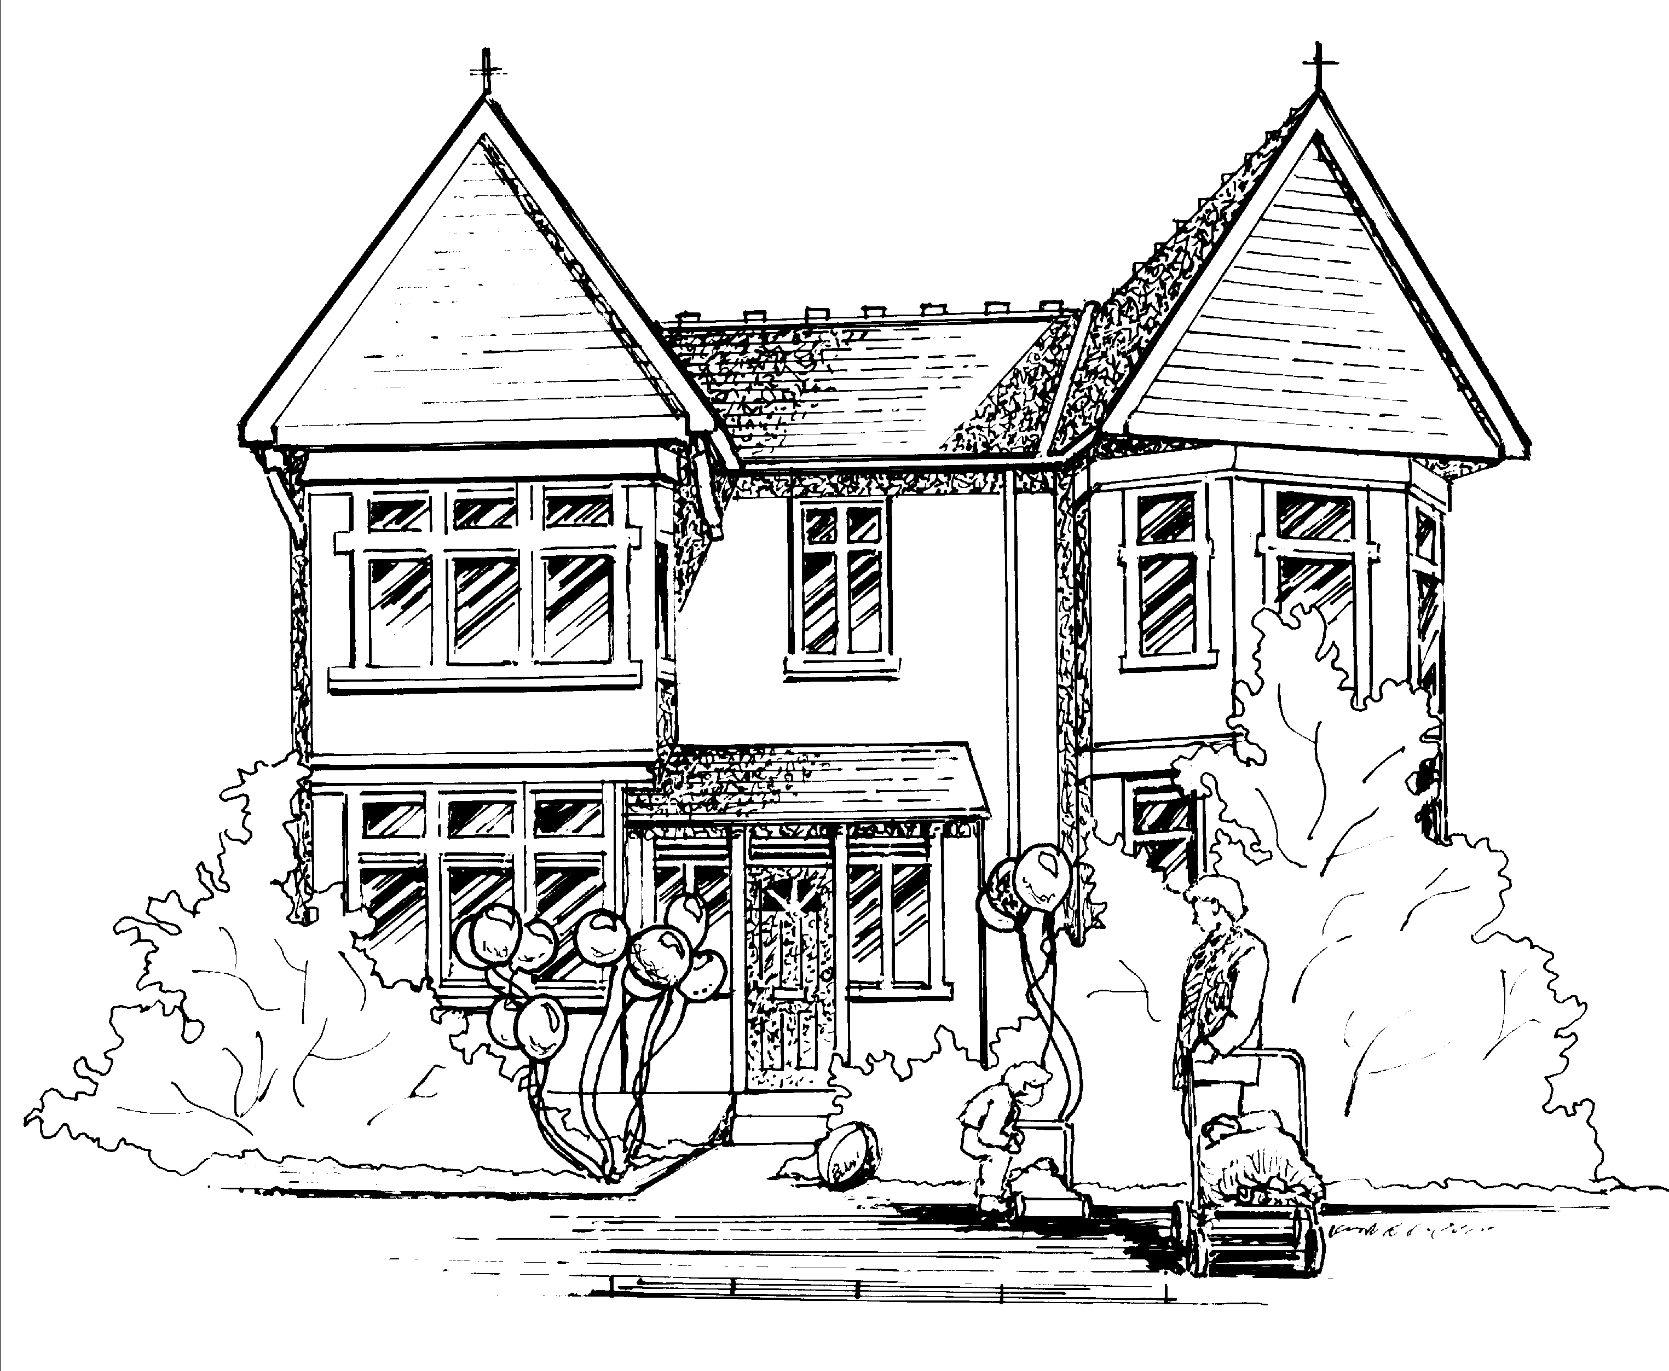

Hi all,

Baby Room
This week the babies have enjoyed listening to and moving to music. They are continuing with learning about Autumn through sensory activities using leaves, paint and mark making. They enjoyed going on a walk to the park where they watched the leaves fall from the trees and collected some to explore back at the nursery.

Toddler Room
This week the toddlers have enjoyed sensory play in orange cornflour and explored the inside of the pumpkins with interest. They enjoyed celebrating Halloween where some children dressed up and took part in making ghosts using their handprints.
It is with a heavy heart that we are saying goodbye to Misha today. She will be missed by all children, parents and staff alike. We wish her the very best of luck back at home in Botswana.

Pre-School and Nursery Class.
This week the children have had lots of fun getting ready for Halloween. They enjoyed making biscuits that looked like pumpkins which they iced and decorated, sticking onto pre-cut spiders and pumpkins and making witches potions and soup! They all enjoyed dressing up and having their faces painted as Halloween characters.
The book of the week has been “Lift the flap colours” which was brought in by one of the pre-school children and encouraged the children to talk about the different colours they could see around the room.
Our letter of the week next week will be ‘f’ Firefighter Fred if you could encourage your child to find an object beginning with this letter for them to show to their peers during group discussions.
Please can parents ensure they are regularly emptying out they children’s art folders which are on the shelf by the water tray.

Notices.

Makaton
This week the children have been learning the Makaton sign for ‘November’ for information on Makaton please go to www.makaton.org

Claire.

